# DR. SRINIBASH DASH

# ASSOCIATE PROFESSOR & HEEAD

# SCHOOL OF MANAGEMENT, GMU,SBP

# Maslow’s Hierarchy of Needs

Maslow’s Hierarchy of Needs theory shows that an individual has a hierarchy of five needs that shape his reaction to any particular situation.

Human has a hierarchy of 5 needs;

1. Physiological.
2. safety needs.
3. Social.
4. Esteem
5. Self-actualization.

Here the Physiological and safety needs are described as lower-order and Social, esteem, and self-actualization are higher-order needs. After satisfying one need will the person will move to satisfy next one.

The Maslow’s hierarchy of needs is a theory proposed by Abraham Harold Maslow in his 1943 paper “A Theory of Human Motivation”.

Maslow, a famous psychologist tried to understand [**human motivation**](https://www.iedunote.com/motivation-definition-meaning). Abraham Maslow’s hierarchy of needs is the most well-known theory of motivation.

Here A.H. Maslow has shown that an individual has a hierarchy of needs that shape his reaction to any particular situation. Maslow advanced the following important propositions about human behavior;

* **The man is a wanting being:** Man always wants and he wants more. But what he wants depends upon what he already has. As soon as one of the man’s needs is satiated, another appears in the place. This process is unending and continuous from birth to death.
* **A satisfied need is not a motivator:** A satisfied need is not a motivator of human behavior. Only the unsatisfied needs motivate behavior.
* **A Need can be arranged in a number of levels:** When a need can be arranged in a number of levels a hierarchy is formed. The satisfaction of lower level needs demands the fulfillment of the next level. That is, human needs move in an ascending order, from the lowest to the highest levels.

According to Maslow, each person had a different set of needs at the different point of time in his life.

He said that all needs of humans could be arranged in a hierarchy. Each person is said to move through the hierarchy by fulfilling each level of needs.

Some people may have dominant needs at a particular level and thus never move through the entire hierarchy. He hypothesized that within every human being there exists a hierarchy of five needs.

Let us see what is meant by of each of these needs:

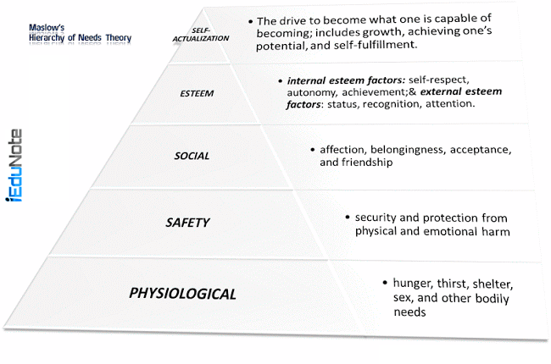

## Hierarchy of Needs: 5 Needs of Human

## Physiological Needs

These are the basic needs for the maintenance of human life. These are the basic needs of the organism—food, water, shelter, clothing, sexual satisfaction and the like.

Maslow took the positions that until these needs are satisfied to the degree necessary to maintain life other needs will not motivate people.

## Safety Needs

These are the needs to be free from physical danger and the fear of loss of a job, property, food, or shelter.

## Social Needs

Since people are social beings, they need to belong and to be accepted by others. Social needs are; physical association and contact, belongingness, love and affection, acceptance by fellows and the like.

## Esteem Needs

If other needs are reasonably satisfied then ego needs become a motivator. People want to be held in esteem both by themselves and by others.

This kind of need produces such satisfactions as power, prestige, status, and self-confidence.

It includes internal esteem factors such as self-respect, autonomy, and achievement; and external esteem factors such as status, recognition, and attention

## Self-Actualization Needs

Maslow regards this as the highest need in his hierarchy. It is the desire to become what one is capable of becoming—to maximize one’s potential and to accomplish something.

It is apparent that it is impossible to motivate workers by satisfying all of the above-mentioned needs. It is not valid for the workers in developing countries. It may be somewhat true for developed countries.

The levels are presented in the form of a triangle or a pyramid with the largest and most fundamental levels of needs at the bottom tier, and the need for self-actualization at the top.

As a need becomes substantially satisfied, the next need becomes dominant. No need is ever fully gratified; a substantially satisfied need no longer motivates.

According to Maslow physiological, security, social, and esteem needs are deficiency needs or D-needs that arise because of deprivation.

The highest level of the pyramid is called the growth needs or B-needs. Maslow separated the five needs into higher and lower orders;

* Physiological and safety needs are described as lower-order.
* Social, esteem, and self-actualization arc as higher-order needs.
* Higher-order needs are satisfied internally.
* Lower-order needs are predominantly satisfied externally.

## Criticism of Maslow’s Hierarchy of Needs:

Maslow’s concept of Need-hierarchy has been subjected to considerable research. Researchers have raised questions about the accuracy of the hierarchical aspects of these needs. Maslow’s Need-hierarchy theory is criticized for the following reasons:

1. The limitations of this theory lie in the fact that different cultures may cause people to have different hierarchies of needs. People necessarily may not satisfy one level after another and may have other needs not mentioned in the list and may be ready to sacrifice some needs.
2. He describes that after fulfilling one need people jump over the need. But one person can exist in a definite hierarchy at the same time.
3. He has overemphasized on the subjective side of motivation but failed to spell out clearly the objective side of motivation.
4. The theory does not mention the proportion of need that must be satisfied to move to a higher need.
5. The strength of needs varies in between individuals. In one individual social needs may predominate while in another actualization needs may be strongest.
6. Maslow’s theory lacks clarity and consistency which are the prerequisites for the formation of a theory. Maslow has failed to show empirical evidence to support his theory.
7. Maslow provided conflicting images of the self-actualized man.
8. Maslow has over-emphasized the subjective side of motivation but he has failed to spell out clearly the objective side of motivation.
9. Needs do not always follow a hierarchy, especially after lower level needs are satisfied.
10. The upward movement of needs results from upward career changes and not from the satisfaction of lower-order needs.
11. In almost all groups satisfaction of needs is definitely more or less insufficient.

Thus; Maslow’s hierarchy of needs theory is not only outdated but also limited in its usefulness to act as an all-encompassing theory of human motivation.

Maslow’s need theory has received wide recognition, particularly among practicing managers.

Research does not generally validate the theory. Maslow provided no empirical substantiation and several studies that sought to validate the theory found no support for it.

# Two-Factor Theory of Motivation – Hygiene and Motivational Factor

Herzberg’s two-factor theory of motivation is based on two types of factors. These factors are satisfiers (motivational) and dissatisfy (maintenance or hygiene). Frederick Herzberg’s two-factor theory is also known as the motivation-hygiene theory. Frederick Herzberg a well-known management theorist developed a specific content theory of work motivation; developed his theory by interviewing 200 accountants and engineers employed by firms in and around Pitsburg in the 1950s.The purpose of his study was to find out what people want, and what motivates them. He asked them to recall occasions when they had been satisfied and motivated and occasions when they had been dissatisfied and unmotivated. Surprisingly, he found that different sets of factors were associated with satisfied and with dissatisfaction that is, a person might identify “low pay’’ as causing dissatisfaction but would not necessarily mention “high pay” as a cause of satisfaction.

Instead, different factors such as recognition or accomplishment-were cited as causing satisfaction and motivation. Proposed by psychologist Frederick Herzberg when he investigated the question, “What do people want from their jobs?”

He asked people to describe, in detail, situations in which they felt exceptionally good or bad about their jobs. These responses were then tabulated and categorized.

Herzberg’s motivation theory is based on two types of factors. These factors are satisfiers (motivational) and dissatisfy (maintenance or hygiene).

Dissatisfied include the factors of company policy and administration, salary, supervision, working conditions, interpersonal relations, status, job security, and personal life.

However; dissatisfies are not motivators.

The satisfiers are motivators and therefore related to job content. They include factors like achievement, recognition, challenging work, advancement, responsibility and growth in the job. Their existence yields feelings of satisfaction.

The first group of factors is called maintenance factors.

Their presence will not motivate people, yet they must be present. They provide an almost neutral feeling among the people of an organization, but their withdrawal or absence creates dissatisfaction.

The second group, or the job content factors, are found to be the real motivators; because they have the potential of yielding a sense of satisfaction.

To summarize the Two-factor theory;

* Intrinsic or satisfiers (motivational) factors, such as advancement, recognition, responsibility, and achievement seem to be related to job satisfaction.
* Dissatisfied respondents tended to cite extrinsic or hygiene (maintenance) factors, such as supervision, pay, company policies, and working conditions.
* The opposite of satisfaction is not dissatisfaction.
* Removing dissatisfying characteristics from a job does not necessarily make the job satisfying.

Job satisfaction factors are separate and distinct from job dissatisfaction factors. Managers who eliminate job dissatisfaction factors may not necessarily bring about motivation.

When hygiene factors are adequate, people will not be dissatisfied; neither will they be satisfied. To motivate people, emphasize factors intrinsically rewarding that are associated with the work itself or to outcomes directly derived from it.

## Criticism of Herzberg’s Two Factor Theory:

Herzberg’s theory has, however, been criticized by many authors. The criticism of the theory is based on the following points.

* The factors leading to satisfaction and dissatisfaction are not different from each other. It has been contended that achievement, recognition, and responsibility are important for both satisfaction and dissatisfaction, while such dimensions as security, salary, and working conditions are less important;
* The two-factor theory is an over-simplification of the true relationship between motivation and dissatisfaction. Several studies showed that one factor can cause job satisfaction for one person and job dissatisfaction for another.
* Herzberg’s inference regarding differences between satisfiers and motivators cannot be completely accepted. People generally attribute the causes of satisfaction to their achievements. But more likely they attribute their dissatisfaction to obstacles presented by the company’s policies or superiors than to their deficiencies.

Though Herzberg’s theory has met severe criticism, it has cast a new light on the content of work motivation. It has contributed substantially to [**Maslow’s ideas and made them more applicable to the work situation**](https://www.iedunote.com/hierarchy-of-needs). It has also contributed to job design techniques or job enrichment.

Regardless of criticisms, [**Herzberg’s theory has been widely read**](https://www.iedunote.com/maslow-herzberg-theory-comparison), and few managers are unfamiliar with his recommendations. The popularity of vertically expanding jobs to allow workers greater responsibility can probably be attributed to Herzberg’s findings.

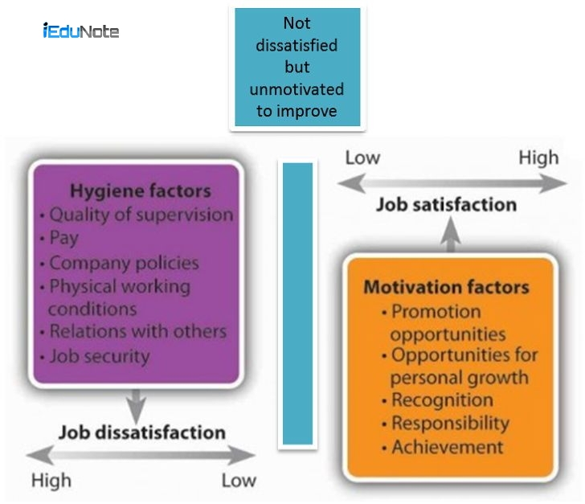

**Comparison of Maslow and Herzberg Theory of Motivation**

Comparison of Maslow and Herzberg’s [**Theory of Motivation**](https://www.iedunote.com/motivation-definition-meaning) shows the similarities and differences between the hierarchy of needs and [**two-factor theory**](https://www.iedunote.com/two-factor-theory). Maslow and Herzberg provided the most popular human motivation theories used in the workforce.

## Similarities of Maslow and Herzberg Theory of Motivation

There is a great similarity between Maslow’s and Herzberg’s models of motivation.

A close examination of Herzberg’s model indicates that for those employees who have achieved a level of social and economic progress in the society, higher-level needs of Maslow’s model (esteem and self-actualization) are the primary motivators.

However; they still must satisfy the lower level needs for the maintenance of the current state.

So we can say that money might still be a chief motivator for most of the operative employees and also for some low paid managerial people.

Herzberg’s model distinguishes the two groups of factors, namely, motivational and maintenance, and points out that the motivational factors are often derived from the job itself.

Most of the maintenance factors come under comparatively lower-order needs and motivational factors are somewhat equivalent to higher-order needs.

Both models assume that specific needs energize behavior.

Although there are marked similarities in the two models, many differences exist which are shown in the following way:

## Differences Between Maslow and Herzberg Theory of Motivation;

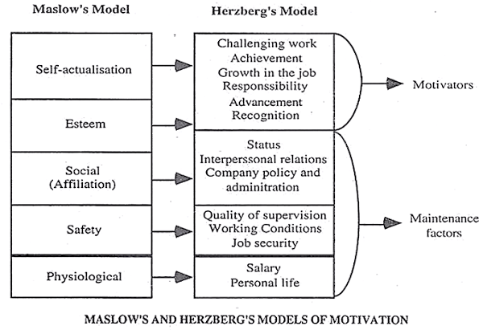

| **Why is Maslow’s and Herzberg’s Theory of Motivation different?** | | |
| --- | --- | --- |
| **Issue** | **Maslow’s Model** | **Herzberg’s Model** |
| Order of needs | The hierarchical arrangement of needs. | No such hierarchical arrangement. |
| Emphasis | Descriptive. | Prescriptive |
| The essence of the theory | Unsatisfied needs energize behavior; this behavior causes performance. | Gratified needs cause performance. |
| Motivator | Any need can be a motivator if it is relatively unsatisfied. | Only higher-order needs serve as motivators. |
| Applicability | Takes a general view of the motivational problems of all workers. | Takes a micro-view and deals with work-oriented motivational problems of professional workers |
| Factors | The existence of some factors creates a positive attitude and their non-existence creates a negative attitude. | The positive and negative factors are completely different. |

## Conclusion

The main difference between them is that; the basis of Maslow’s theory is human needs and their satisfaction. On the other hand, Herzberg’s theory relies on reward and recognition.